Overview
From the Fact sheets screen you can view fact sheets online, download, print or save DVA fact sheets. Alternatively, you can request fact sheets be sent to you by mail.

The Fact sheets screen.
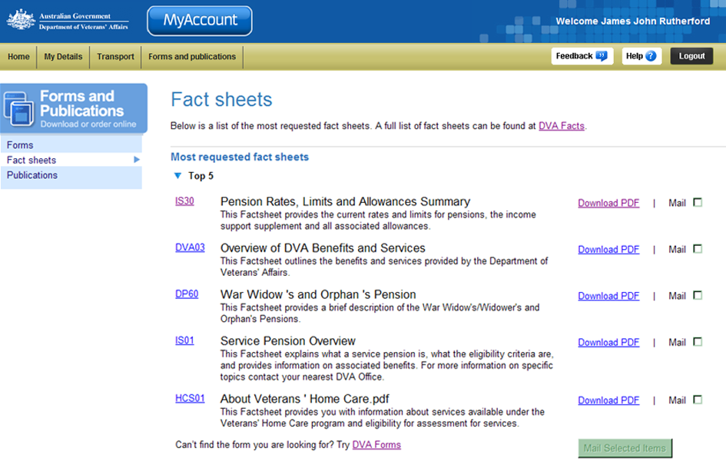
Forms and Publications menu.
Most requested fact sheets list.
DVA Facts link.
Fact sheet reference number links.

Most requested fact sheets - Top 5
The top five most requested fact sheets are displayed in the first section at the top of the screen.

Other fact sheets
Below the Top 5 section, additional commonly requested fact sheets are grouped according to type. To expand a group, click on the icon (twistie).
If you are unable to locate the fact sheet you are looking for, click on a DVA Facts link located at the top and bottom of the Top 5 section.

View a fact sheet
To view a fact sheet online:
- For the fact sheet you are interested in, click on the fact sheet reference number link to the left of the fact sheet name and description.

The fact sheet displays in a new window.
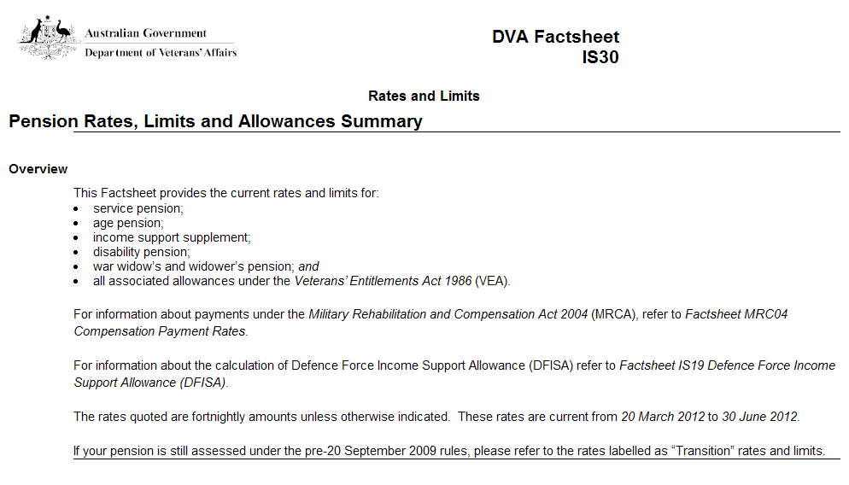
- When finished, close the widow.
You have successfully viewed the fact sheet.

Download a fact sheet
To view downloaded fact sheets you need a copy of Adobe Reader (or Adobe Acrobat). This may already be installed on your computer.
If required, you can get a free copy of Adobe Reader at: http://get.adobe.com/reader/
To download and print a fact sheet:
- For the fact sheet you are interested in, click on the Download PDF link to the right of the fact sheet name and description.

The File Download dialog box displays.
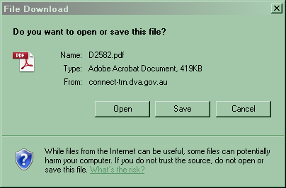
- Click on the Open button.

The fact sheet displays in Adobe Acrobat.
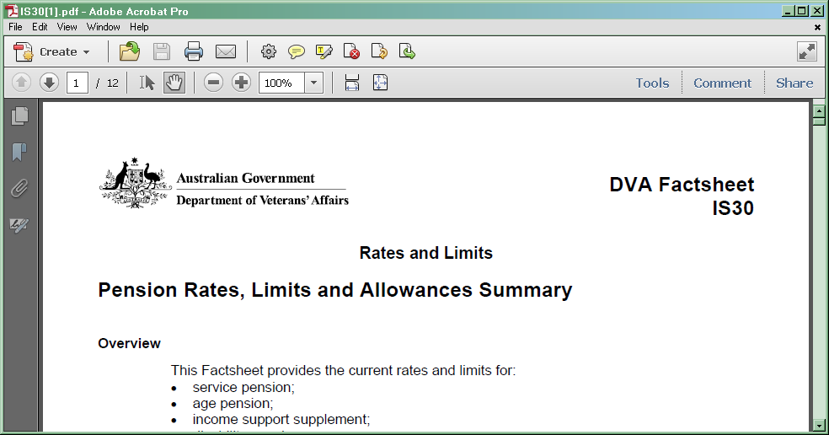
- To print a copy of the fact sheet, click on the icon at to the top of the window.
To save a copy of the fact sheet, at the top left of the window click on the File menu > Save As… > PDF… and choose a location and file name for the fact sheet.
You have successfully downloaded the fact sheet.

Request fact sheets be sent by mail.
To request fact sheets be sent to you by mail:
- For the fact sheets you are interested in, select the Mail check box to the right of the fact sheet name and description.
- Click on the Mail Selected Items button.

The Delivery address screen displays.
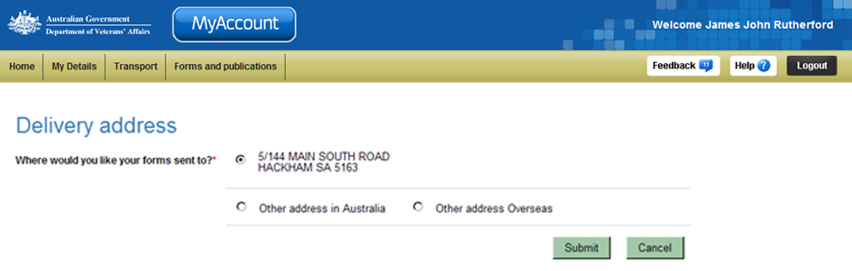
- Select the option to indicate the address you would like the fact sheets sent to.
 | By default, your postal address, as displayed in MyAccount, is selected as the postal address.
- If you selected Other address in Australia or Other address Overseas, go to Step 5. Otherwise, go to Step 6.

The Delivery address screen updates.
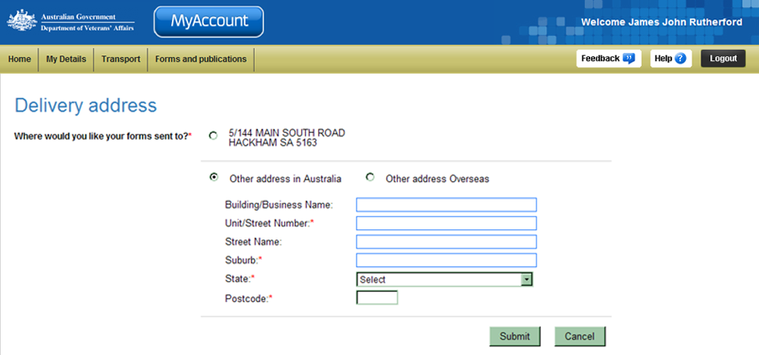
- Complete the address fields. Fields marked with a red asterisk (*) are mandatory.
- Click on the Submit button.

The MyAccount Home screen displays.
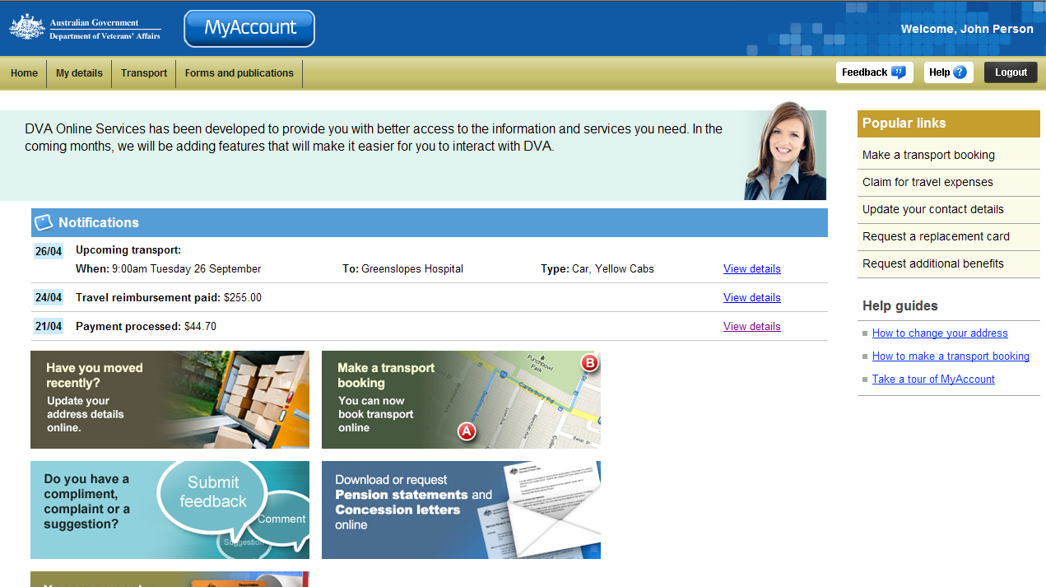

The Fact sheets screen displays.
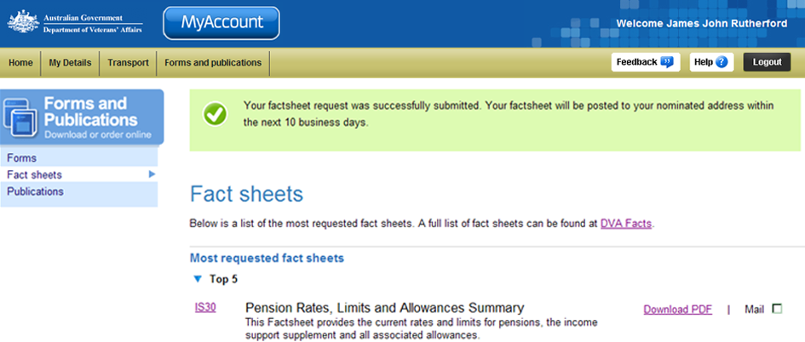
At the top of the screen, a green success message states your request was successfully submitted. Your documents will be posted on the next working day and you should receive them within 10 business days.

Other functions
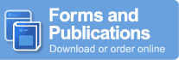 | To view another section and information from Forms and publications, click on a link in the Forms and Publications menu to the left of the page.
 | To get additional help with the Fact sheets screen, click on the Help button at to the top right of the page.
 | When you are finished using MyAccount, to log out and finish using the service in a secure way, click on the Logout button.

